You are an expert in the PTC process (Product Techcnical Complaints - Context is GMP/GDP compliance) for GBS covering a multi-Country requirement in the frame of Bayer and product specificities. You can find all details attached: global SOPs, Country Specific SOP, and user letters with product specificities and other ones. As expert, you have to create a comprehensive map of the process, but I do not know the best way to represent it. Analyze the documentation and tell me the different options I have at disposal.

Comprehensive Analysis of the PTC Process – Options for Process Mapping
Based on my thorough analysis of all your documentation uploaded, I have identified a rich and complex process ecosystem. Before recommending mapping options, let me first summarize what I found, so you understand the scope and dimensions that any process map must capture.

📋 Documentation Inventory Identified

1. Global-Level Documents
Document | Description
GSOP 115 | "Manage Product Technical Complaints and Suspected Falsification and Counterfeit Incidents" – the Bayer corporate-level global SOP 48
SSC-PTC-SOP-001 (IQMS-50911, Ver. 6.0) | "Manage Product Technical Complaint and Suspected Counterfeit Incidents in GBS" – the GBS-level global SOP that all country-specific SOPs reference as their framework 85

2. Country-Specific SOPs (identified)
Doc Number | Country/Region | IQMS ID
SSC-PTC-SOP-ES-002 | Spain | IQMS-59667 68
SSC-PTC-SOP-PT-003 | Portugal | IQMS-33695 84
SSC-PTC-SOP-CA-004 | Canada | IQMS-91277 33
SSC-PTC-SOP-BY-005 | Belarus | IQMS-70232 52
SSC-PTC-SOP-NO-DK-IS-008 | Norway, Denmark, Iceland | IQMS-97854 61
SSC-PTC-SOP-IT-011 | Italy | IQMS-96211 76
SSC-PTC-SOP-DE-012 | Germany | IQMS-60870 83
SSC-PTC-SOP-UK-IE-MLT-013 | UK, Ireland, Malta | — 21
SSC-PTC-SOP-FR-015 | France | IQMS-99848 88
SSC-PTC-SOP-ME-IR-016 | Middle East / Iran | IQMS-95735 54
SSC-PTC-SOP-BELUX-002 | Belgium & Luxembourg | IQMS-64489 32
SSC-PTC-SOP-PL-* | Poland | — 59
SSC-PTC-SOP-TW-002 | Taiwan | IQMS-58554 34
SSC-PTC-SOP-HK-003 | Hong Kong | IQMS-61479 85
SSC-PTC-SOP-KR-* | South Korea | — 46
SSC-PTC-SOP-ID-* | Indonesia | — 4
SSC-PTC-SOP-RU-* | Russia/CIS (incl. Georgia, Azerbaijan, Armenia, Uzbekistan, Turkmenistan, Mongolia) | — 23
SSC-PTC-SOP-US-005 | USA (PH/BT) | IQMS-14847 63
SSC-PTC-SOP-US-*-CH | USA (CH) | — 11
SSC-PTC-SOP-RD-* | Radiology Division (cross-country) | — 60

3. User Letters & Best Practice Documents
Document Type | Product/Topic
User Letter – Breelib | Breelib device complaint handling via PHD Lifescience S.r.l. 56
User Letter – BetaConnect | BetaConnect device, Safe Track Reports 37
User Letter – Multiple Manufacturers | Handling complaints where manufacturing site is unknown 51
User Letter – IUS (Mirena/Kyleena/Jaydess) | IUS breakage handling, LODE cases 9
User Letter – Expired Devices | BetaConnect expired device disposal 55
Best Practice (SSC-PTC-BP-002) | Country-specific SOP template 41

🔑 Key Process Dimensions Identified
The PTC process has multiple dimensions that any comprehensive map must address:

A. Core Process Steps (End-to-End)
- Complaint Receipt (from patients, HCPs, pharmacies, hospitals, wholesalers, health authorities, call centers) 45
- Initial Intake & Triage – determine if PTC, Usability Issue, Suspected Counterfeit, non-PTC 9
- Data Entry in IQMS/Complaint Database in English 17
- Initial Risk Classification (High, Medium, Low) 53
- Escalation/Notification to CQU, PV, Health Authorities as applicable 45
- Acknowledgement Letter to complainant 56
- Sample Handling (request, collection, shipping to RQU) 15
- Forwarding to RQU for investigation 85
- Gathering Additional Information / follow-up attempts 58
- RQU Investigation & Assessment 85
- Final Risk Classification 42
- Response Letter (before or after closing, depending on country) 16 17
- Reimbursement/Replacement (country-dependent) 17
- Case Closure (GBS or CQU depending on risk class and country) 55

B. Decision Points / Branching Logic
- Is it a PTC, Usability Issue, Suspected Counterfeit, or non-PTC? 9
- Is there an associated AE or LODE? → PV notification required 45
- Risk Classification: High, Medium, or Low? → different timelines and escalation 53
- Health Authority involvement? → CQU must handle 42
- Suspected Counterfeit? → immediate CQU escalation 59
- Division: PH, CH, or Radiology? → different sample handling and contact rules 15
- Who closes the case? → depends on country and risk class 55

C. Roles & Stakeholders
- GBS PTC Team (officers in Barcelona, Gdansk, Manila, Dalian, India, Costa Rica/Brazil, Germany) 18
- CQU / CQH (Country Quality Unit / Head) 85
- RQU (Responsible Quality Unit – manufacturing site) 85
- PV (Pharmacovigilance) 45
- Call Centers (e.g., Conduent for Canada CH) 57
- Patient Support Programs (e.g., PHD Lifescience for Breelib/BetaConnect) 37

D. Country Variations
Each country SOP modifies the global process in areas such as: escalation rules, sample handling, response letter timing, reimbursement, data privacy, language requirements, and who closes the case 45.

🗺️ Options for Comprehensive Process Mapping
Given the complexity above, here are 6 options for representing this process, each with pros and cons:

Option 1: Layered Swimlane Flowchart (BPMN-style)
Description: A multi-lane process flow diagram with horizontal swimlanes for each role (GBS, CQU, RQU, PV, Complainant) showing the end-to-end process from complaint receipt to closure.
✅ Pros | ❌ Cons
Clear role accountability at each step | Becomes very wide/complex with all country variations
Industry-standard (BPMN) notation | Hard to show 20+ country variations on one diagram
Shows handoffs and decision points clearly | May need multiple versions (one global + one per country)
Best for: Showing the global baseline process with clear role responsibilities.

Option 2: Hierarchical Process Map (Multi-Level)
Description: A 3-level decomposition:
- Level 0: High-level end-to-end overview (5-7 macro steps)
- Level 1: Each macro step expanded into sub-steps with decision points
- Level 2: Country-specific variations shown as annotations or variant branches
✅ Pros | ❌ Cons
Manages complexity through progressive detail | Requires multiple linked diagrams
Allows stakeholders to zoom in/out | Country variations still complex at Level 2
Aligns well with SOP document hierarchy (GSOP → GBS SOP → Country SOP) | Needs a good navigation/index system
Best for: Mirroring the document hierarchy (GSOP 115 → SSC-PTC-SOP-001 → Country SOPs → User Letters).

Option 3: Matrix / Cross-Reference Map
Description: A large matrix with:
- Rows: Process steps (intake, classification, sample handling, acknowledgement, investigation, response, closure, etc.)
- Columns: Countries/regions
- Cells: Country-specific rules, responsible party, timeline, template reference
✅ Pros | ❌ Cons
Excellent for comparing country differences side-by-side | Not a visual "flow" – more of a reference table
Easy to maintain and update | Doesn't show decision logic or branching
Ideal for training and quick-reference | Can become very large (20+ columns × 15+ rows)
Best for: Operational quick-reference for PTC officers who need to look up "what do I do for Country X at Step Y?"

Option 4: Decision Tree / Flowchart with Country Branching
Description: A decision-tree style diagram that starts with the complaint receipt and branches based on key decision points: type of complaint → division → risk classification → country → specific handling rules.
✅ Pros | ❌ Cons
Excellent for showing the decision logic | Can become very "bushy" with many branches
Guides the user step-by-step | Hard to show the full end-to-end flow
Captures the "if-then" rules from all SOPs | May need to be split into sub-trees
Best for: Decision support – helping PTC officers navigate the right path through the process.

Option 5: Integrated Process Map with Overlay Layers (Digital/Interactive)
Description: An interactive digital map (e.g., in Visio, Miro, Lucidchart, or a web-based tool) where:
- The base layer shows the global SSC-PTC-SOP-001 process
- Toggle-able overlay layers show country-specific variations, product-specific rules (Breelib, BetaConnect, IUS), and division-specific rules (PH, CH, Radiology)
- Clickable elements link to the actual SOP documents and templates
✅ Pros | ❌ Cons
Most comprehensive and user-friendly | Requires a digital tool and maintenance effort
Handles complexity through layers/filters | Not printable as a single static document
Can link directly to SOP documents and templates | Needs initial investment to build
Scalable – easy to add new countries | Requires training for users
Best for: A living, operational tool that serves as the single source of truth for the entire PTC process.

Option 6: Hybrid Approach (Recommended)
Description: Combine multiple representations:
- One global swimlane flowchart (Option 1) for the SSC-PTC-SOP-001 baseline process
- One country comparison matrix (Option 3) for the key variation points across all countries
- One decision tree (Option 4) for the triage/classification logic
- Product-specific sub-process maps for Breelib, BetaConnect, IUS devices
- A document hierarchy diagram showing how GSOP 115 → SSC-PTC-SOP-001 → Country SOPs → User Letters relate
✅ Pros | ❌ Cons
Each representation serves a different audience/purpose | More artifacts to create and maintain
Comprehensive coverage of all dimensions | Needs clear cross-referencing between maps
Can be built incrementally | Requires a "master index" to navigate
Suitable for both training and daily operations
Best for: Maximum comprehensiveness while keeping each individual artifact manageable.

🎯 My Recommendation
Given the complexity of your PTC process — spanning 20+ countries, 3 divisions (PH, CH, Radiology), multiple product-specific rules, 7 GBS locations, and a 3-tier document hierarchy — I would recommend Option 6 (Hybrid Approach) as the most effective strategy.
The priority order for building would be:
- Start with the global swimlane flowchart (the backbone)
- Then build the country comparison matrix (highest operational value)
- Then add the decision tree for triage
- Then create product-specific sub-maps
- Finally the document hierarchy diagram
Would you like me to start building any of these specific representations?

Start with the global swimlane flowchart (the backbone)

Global Swimlane Flowchart for PTC Process

Swimlanes:
- GBS PTC Team
- Country Quality Unit (CQU)
- Responsible Quality Unit (RQU)
- Pharmacovigilance (PV)
- Complainant

Process Steps:

1. Receive Case
- GBS PTC Team: Acknowledge receipt of the case and log initial details into the tracking system. 0

2. Intake
- GBS PTC Team:
  - Read Email: Open the email and read the text. 1
  - Is it PTC? Verify if the case pertains to a PTC by checking predefined criteria. 2
  - Categorization: Assign a category based on the nature of the complaint. 3
  - Complaint Data in Place: Ensure all necessary complaint data is available and complete. 4
  - Forward Non-PTC: If the case is not PTC, forward it to the appropriate department. 5
  - Add New Data: Update the system with any new information received. 6
  - Gather Additional Information: Collect any additional information needed to proceed with the case. 7

3. Enter into Database
- GBS PTC Team:
  - Enter Case: Log the case details into the database. 8
  - Enter Safety Database Number: Assign a safety database number to the case if applicable. 9
  - Perform Sample Handling: Handle any samples associated with the case as per protocol. 10
  - Assign Responsible RQU: Designate the responsible RQU for case management. 11
  - Inform All Relevant Responsible People: Notify all stakeholders involved in the case. 12
  - Check Completeness: Ensure all necessary information is complete before proceeding. 13
  - Forward Complaint Case: Forward the case to the next stage in the process. 14

4. Investigate Case and Finally Assess
- RQU: Conduct a thorough investigation and assess the findings to determine the next steps. 15

5. Close Case
- GBS PTC Team: Finalize the case documentation and close it in the system. Ensure that all necessary documentation is included and that the plausibility of the investigation is checked. 16

6. Respond to Complainant
- CQU: Communicate the outcome of the case to the complainant, including sending an acknowledgment letter and any necessary response letters. 17

Timelines (from Chapter 4.1.2):
- Initial Response Time: Respond to the complainant within 24 hours of receiving the case. 18
- Investigation Duration: Complete the investigation within 7 business days. 19

Escalation Rules:
- Escalation Criteria: Escalate cases that meet the predefined criteria for severity or complexity to senior management. 20
- Escalation Procedure: Follow the outlined procedure for escalating cases, ensuring all relevant documentation is included. 21
This outline provides a comprehensive view of the PTC process, which can be translated into a visual swimlane diagram. Each role has clearly defined responsibilities and interactions throughout the process.
Would you like me to assist you in creating a visual representation of this flowchart, or is there anything else you would like to add or modify?
Create a visual representation of this flowchart

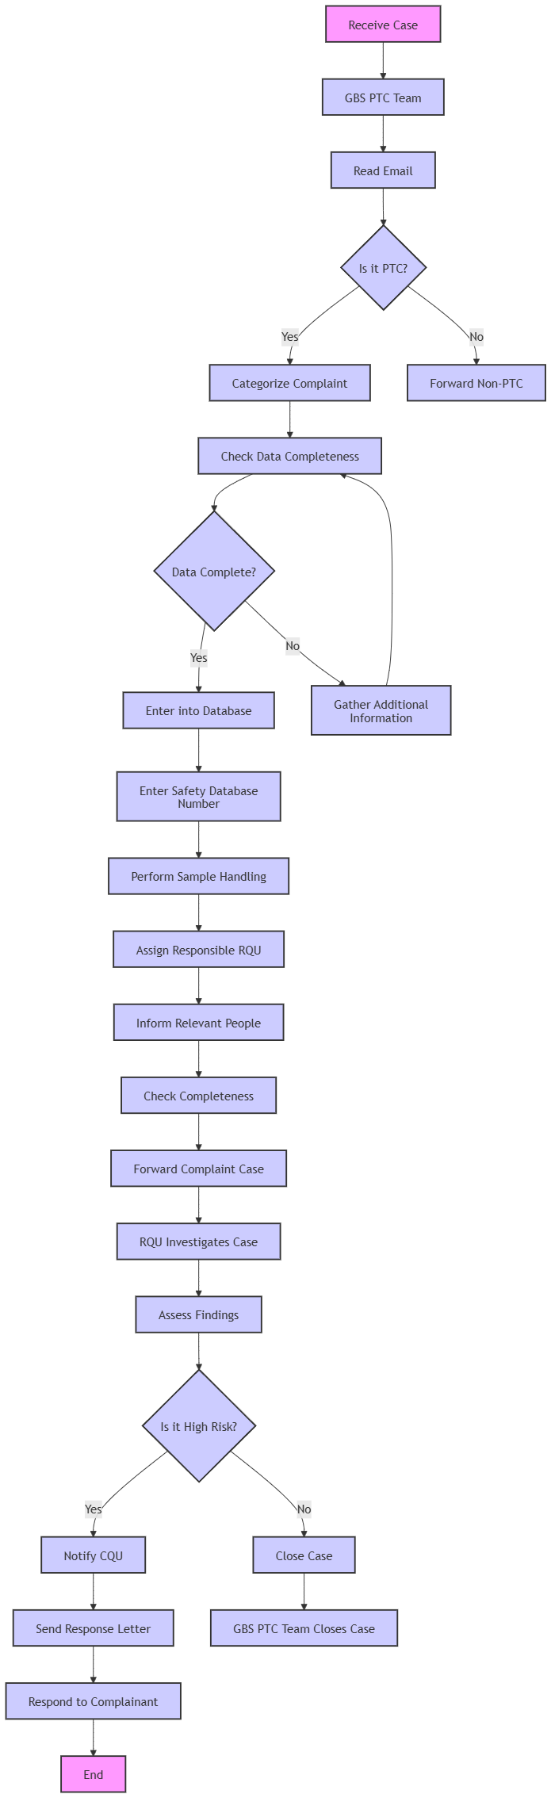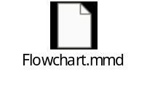

Let's move to step 2: build the country comparison matrix (highest operational value)

PTC Process: Country Comparison Matrix

See Excel

NEW 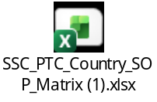

OLD 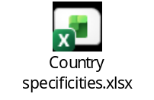)
Let's move to step 3: add the decision tree for triage

Decision Tree for PTC Triage Process
This decision tree guides the GBS PTC Team through the initial intake and classification of a complaint.
Start: Complaint Received by GBS PTC Team

1. Initial Assessment: Is it a Complaint?
- Is the reported issue a Product Technical Complaint (PTC)?
  - YES, if it involves (including suspicion) 9:
    - Broken or damaged devices
    - Missing components, parts, units, or variable data imprints
    - Deviations in product appearance (color, odor, spots)
    - Contamination or foreign matter
    - Deviations in product packaging (leaflet, primary/secondary package)
    - Adverse Event (AE) associated with a quality defect (PTC+AE)
    - Lack of Drug Effect (LODE) associated with a quality defect (PTC+AE)
    - Use errors directly associated with a PV case (e.g., off-label use, misuse, medication error) 125
  - NO:
    - Is it a Usability Issue (without suspected quality defect)? 125
      - YES: Enter into global complaint database. 125 (Proceed to Risk Classification if applicable, then closure/monitoring)
      - NO: Forward to CQU or appropriate function for further processing. 85 END OF THIS BRANCH

2. Initial Classification: PTC Type
- Is it a Suspected Falsification or Counterfeit Incident? 146
  - YES:
    - Immediately escalate to CQH/CQU via notification in the complaint database. 59 147 155
    - Use Annex 3: Pick list for Reporting Suspected Falsification and Counterfeit Incidents. 125
    - END OF THIS BRANCH (CQU takes over lead)
  - NO: Proceed to next step.

3. Division-Specific Triage
- What is the product division?
  - Radiology Medical Device:
    - Process all cases (PTC, PTC+AE, AE) in the complaint database only, not in the PV safety database. 125
    - Follow country-specific SOPs for Radiology products.
    - Proceed to Risk Classification.
  - PH (Pharmaceuticals) / BT (Biotechnology):
    - For Betaseron Injector & Kovaltry: Always request samples, even for Medium/Low risk. 149
    - Proceed to Risk Classification.
  - CH (Consumer Health):
    - Proceed to Risk Classification.

4. Product-Specific Triage (if applicable)
- Is it an IUS (Intrauterine System) product (e.g., Mirena, Kyleena, Jaydess)?
  - YES:
    - If IUS breakage is reported, process as PTC and initiate RQU investigation, even if no batch number or sample is available. 9
    - If received via Third-Party service provider (e.g., Health Loyalty for Canada): They manage sample return, GBS does not request photos/samples. 149
    - Proceed to Risk Classification.
  - Is it Breelib or Betaferon/Autoinjector?
    - YES: Note that 3rd party suppliers/care companies handle replacement. 148 (This impacts later steps, but good to note during triage).
    - Proceed to Risk Classification.
  - NO: Proceed to Risk Classification.

5. Initial Risk Classification (by GBS PTC Team) 97
- Assess potential risk to patient/customer/user/environmental safety 146:
  - High Risk: Potentially life-threatening or serious health risk. 154
    - Examples: Wrong product/strength (serious consequences), microbial/chemical contamination (serious consequences), mix-up of products, wrong active ingredient (serious consequences), serious batch/product-related AE, particles in injectables, high environmental risk. 154
    - Action: Escalate to CQH/CQU via immediate action in the complaint database. 59 147 155
    - Proceed to PV Notification Check.
  - Medium Risk: Could cause illness or mistreatment with potentially non-serious medical consequences, but not High. 154
    - Action: Escalate to CQH/CQU via notification in the complaint database. 59 147 155
    - Proceed to PV Notification Check.
  - Low Risk: (No specific examples provided, but implies less severe than Medium).
    - Proceed to PV Notification Check.

6. PV Notification Check
- Is there a potential associated Adverse Event (AE) or Lack of Drug Effect (LODE)? 123
  - YES:
    - Inform Pharmacovigilance (PV) with unique complaint database number and relevant follow-up information. 123
    - Process as PTC+AE to ensure device report can be submitted (for medical devices/combination products). 125
    - Proceed to Health Authority Notification Check.
  - NO: Proceed to Health Authority Notification Check.

7. Health Authority Notification Check
- Are local Health Authorities involved, or is there an allegation to report to Media/Authority? 150 123 152
  - YES: Inform CQU immediately. 150 123
  - NO: Proceed to Responsible RQU Determination.

8. Responsible RQU Determination
- Determine the Responsible Quality Unit (RQU) 153:
  - Bayer Manufacturing Site Product: RQU is defined at the respective manufacturing site. 153
  - External Global CMO Product: RQU is from divisional QA, External Manufacturing, or Bayer manufacturing sites (e.g., Morristown). 153
  - External Local CMO Product: Country-specific CQH acts as the RQU. 153
  - Reference: Names of RQUs can be found on SharePoint go/ptcops. 153

9. Country-Specific Triage Variations (GBS Complainant Contact)
- Can GBS directly contact the complainant?
  - NO (CQU is sole interface): e.g., Spain, Portugal, Italy, France, Belgium & Luxembourg, Taiwan, Hong Kong, Russia/CIS, Belarus.
    - GBS organizes missing information and asks CQU for support in contacting the complainant (due to data privacy, non-hosted language, local laws). 150 123
    - For Russia/CIS, Belarus: CQU must anonymize personal data before forwarding to GBS.
    - For Poland: Response letters sent only upon complainant request by CQU.
    - Proceed to Complaint Database Entry.
  - YES (GBS can contact directly): e.g., Canada (CH), Germany (CH), Nordics, UK/Ireland/Malta.
    - GBS can directly gather additional information if needed.
    - Proceed to Complaint Database Entry.

10. Complaint Database Entry
- Enter PTC, Suspected Counterfeit Incidents, and Usability Issues into the global complaint database in English language according to defined timelines. 150 123
End of Triage: Case is now classified, risk-assessed, escalated (if needed), and entered into the database, ready for RQU investigation.

Let's move to step 4: create product-specific sub-maps

1 Breelib (Inhalation Device for Ventavis) — Sub-Map (LM Vectura)
PSP responsibilities: PSP receives complaints; documents via Breelib Form or Safe Track; forwards/enters data; contacts complainant if more info needed; receives the IQMS PTC number; ships device to Vectura and informs shipment date.
Shipment traceability rules: Devices individually packaged; accompanied by IQMS PTC number; send to Vectura within two weeks.
IQMS recording/closure constraints: Record shipment/no shipment + reason; one complaint per serial number; new error later = new PTC; do not close locally (incl. use errors).
Complaint description guidance: Include original complainant/PSP description in IQMS "Description"; if submitted via Safe Track, transfer "Additional Context" into "Description"; use proposed key terms/error coding in title.
Special scenario (Ventavis off-label; patient < 18): Process as "PTC only" in IQMS plus "PV-only case in Argus" (cases not linked).
Treatment stop returns: No PTC entry required (cancel with justification "No PTC reported; device deactivation only"); dispose device; no manufacturer notification/return required.
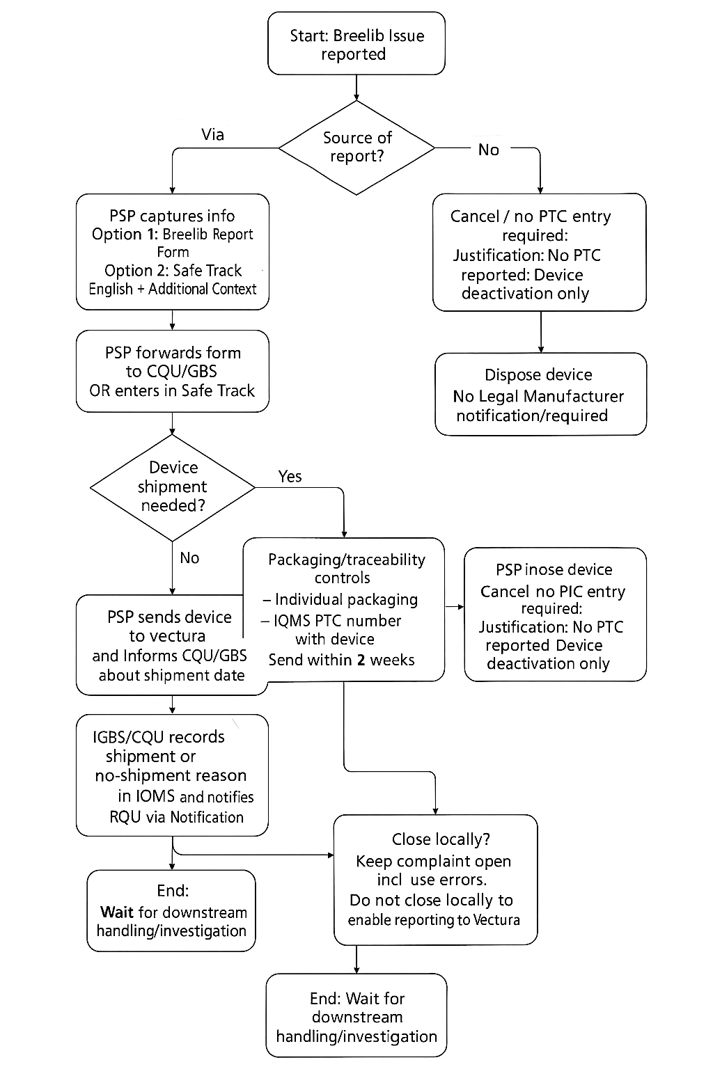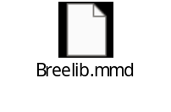

2 BetaConnect (Autoinjector for Betaferon) — Sub-Map (LM Phillips-Medisize)
Betaconnect is manufactured by external Legal Manufacturer Phillips-Medisize A/S (Struer) with Bayer as distributor.
Scenario 1 steps (complainant/PSP → Quality): IQMS entry → forward formatted output to LM; LM acknowledges; gather more info if needed; organize sample retrieval; response letter if requested (with optional Medical Device Quality support); close locally.
PTC+AE handling note: Forward to PV, await/reference Global Safety DB number in IQMS, close locally; CM PQS Rep enters investigation result directly in Global Safety DB upon receipt.
Scenario 2 (PV → Quality): Process as Scenario 1 (steps 1–5) then close PTC+AE locally (no need to forward for investigation/start QSE); LM forwards investigation results to Bayer PV if applicable.
Expired devices: Expired devices with/without PTC can be disposed (exception: AE-related); CQU sends quarterly list of disposed expired devices to LM; documentation stored locally; LM contact email and shipping address provided.
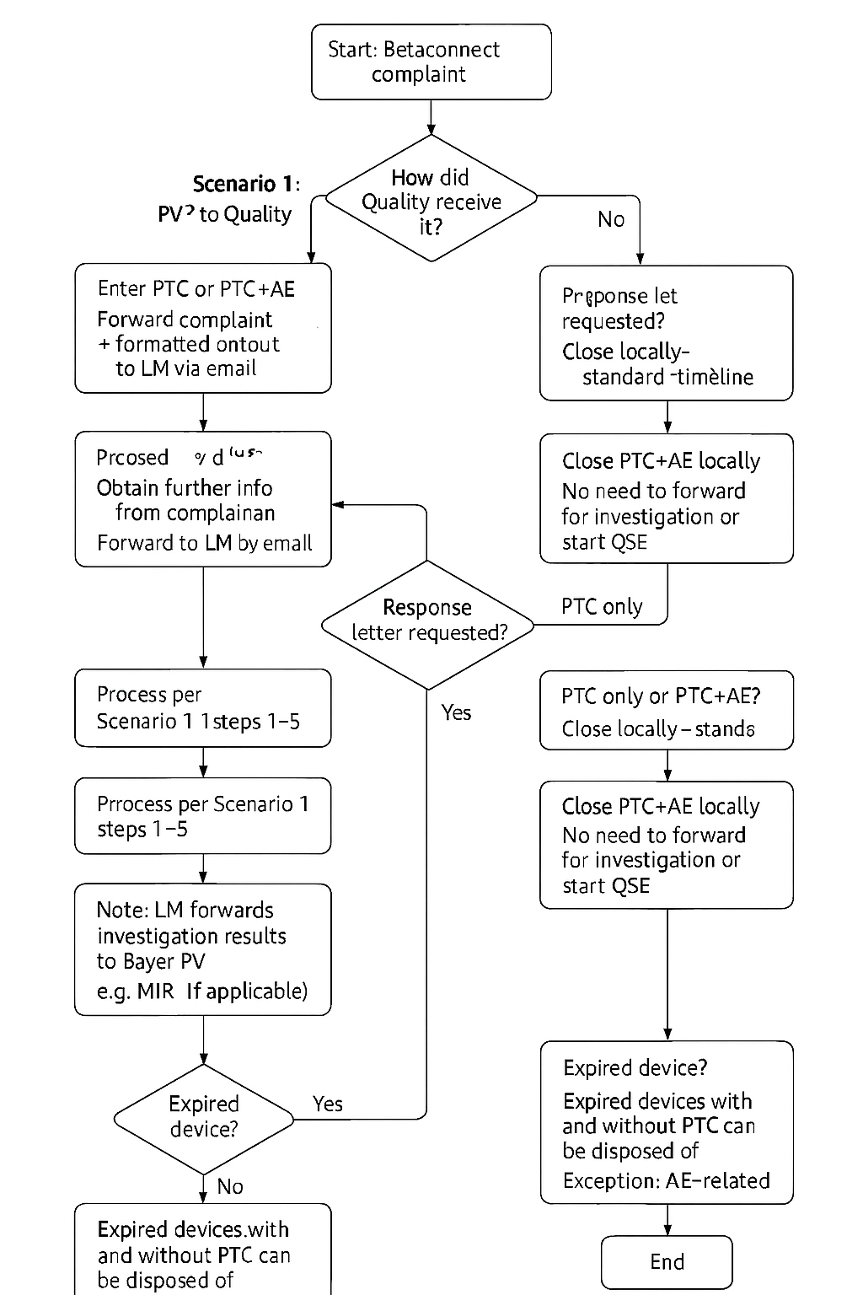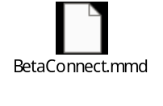

3 IUS (Mirena / Jaydess / Kyleena etc.) — Sub-Map (PTC+AE Investigation Exceptions)
User letter scope includes Mirena, Jaydess, Kyleena, Fleree, Janess, LNG-IUS, Skyla and applies to CQU/GBS/RQU. It clarifies when cases are entered in IQMS and when cases require technical investigation; certain AE scenarios do not require investigation and are periodically reviewed/monitored by Product Supply QA.
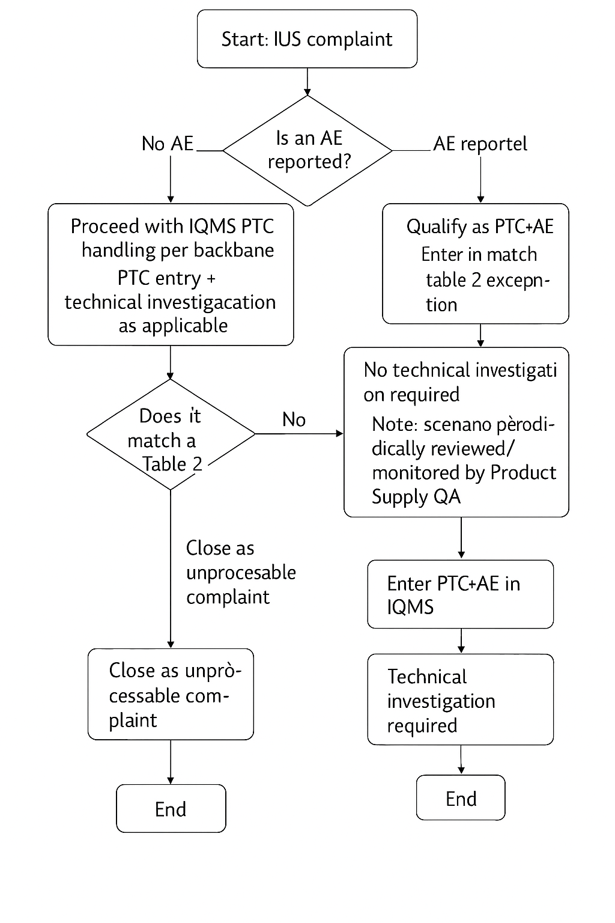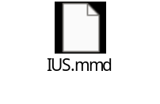

4 Copper IUD (Nova T / Nova T 380) — Sub-Map (Class III; Always Investigate)
Copper IUD products Nova T and Nova T 380 are Class III medical devices and all cases require RQU investigation (full workflow for all cases including usability issues and cases where no sample and/or batch are available). Root cause cannot be investigated without sample; if sample not available, photos shall be provided (rare packaging issues: photos sufficient).
Always investigate: All cases require RQU investigation, including usability issues and even when no sample/batch available.
Sample/photos rule: Sample needed for root cause; if not available, photos shall be provided; rare packaging issues: photos sufficient.
Coding/risk category guidance exists: Table 1 defines Level 1/2/3 error coding + AE types + risk category (not all inclusive).
Example entries: Low-risk categories exist (e.g., "Problem loading" low risk; usability/use error low risk; customer satisfaction issues low risk).
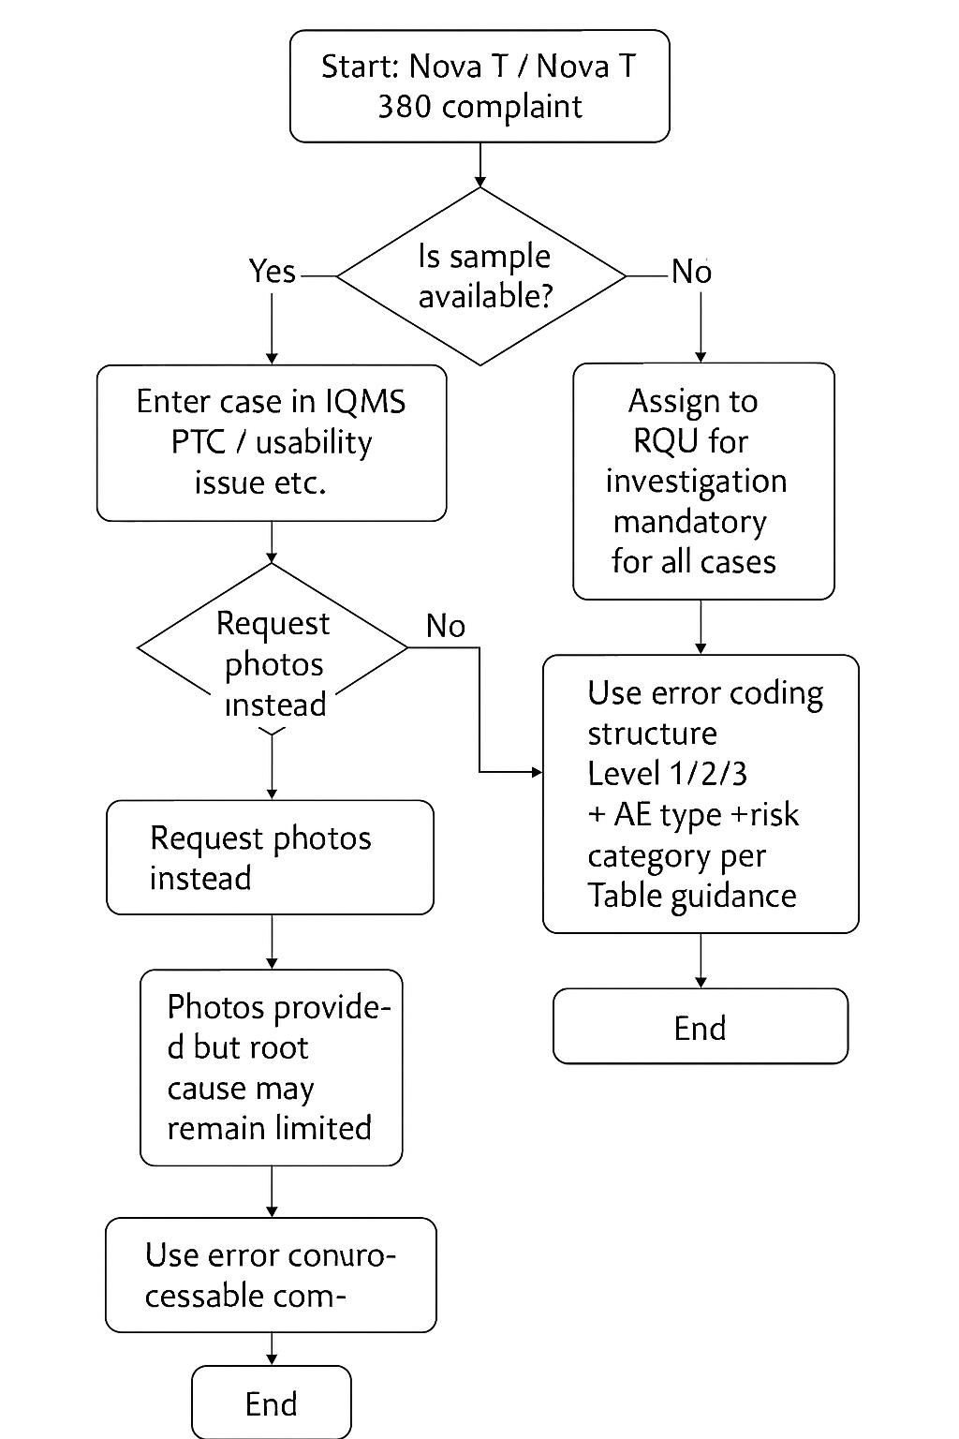

5 Multiple Manufacturers, Site Unknown — Sub-Map (Data Retrieval Attempts + Dummy Site Logic)
For PTC or suspected falsification/counterfeit where only basic product info is available for products manufactured at more than one site, perform/document up to three attempts to retrieve additional information in local system (e.g., Engage). If no local system exists: enter case in IQMS with dummy manufacturing site and high-level product name; document attempts in IQMS; if still no additional info → local closure; if additional info allows identification → enter/send for investigation. PTC+AE cases are out of scope of this user letter and must be processed per GSOP 115.
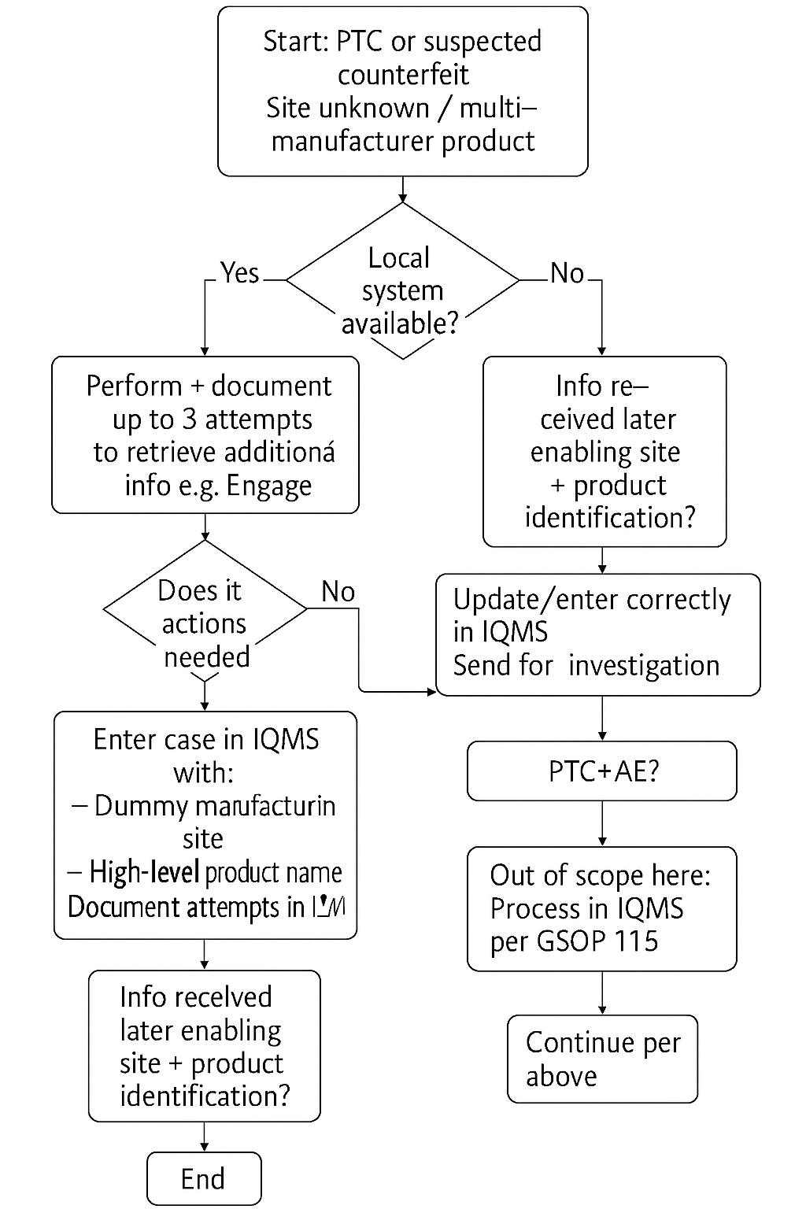

6 Radiology Medical Devices — Escalation Trigger Sub-Map (Death / Air Injection / Extravasation)
Immediate escalation (send complaint to the owner/RQU) is required for radiology medical device complaints if they include allegations of Death, Air Injection, or Extravasation. These complaints must be assigned and sent to RQU within 24 hours (aligned to GSOP 115 section 4.1.2 as referenced).
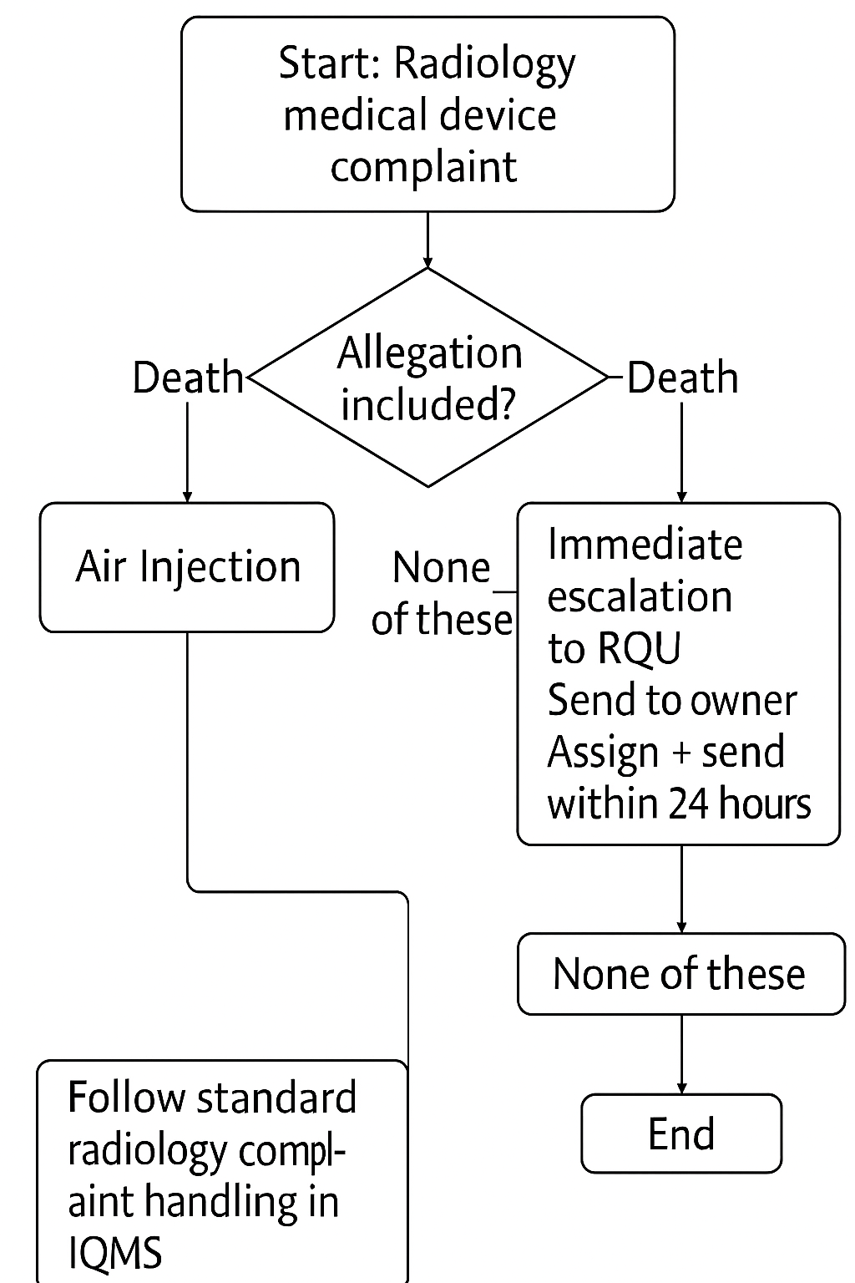

What Cannot Be Shown (From Available Extracts)
- Breelib "under 18 years" Table 1 details beyond the one "Ventavis off-label <18" rule captured above.
- Full IUD Table 1 taxonomy (complete list of Level 1/2/3 error codes and risk categories) — only example rows are available

Finally create the document hierarchy diagram

📐 Document Hierarchy Diagram — PTC Process

Visual Representation
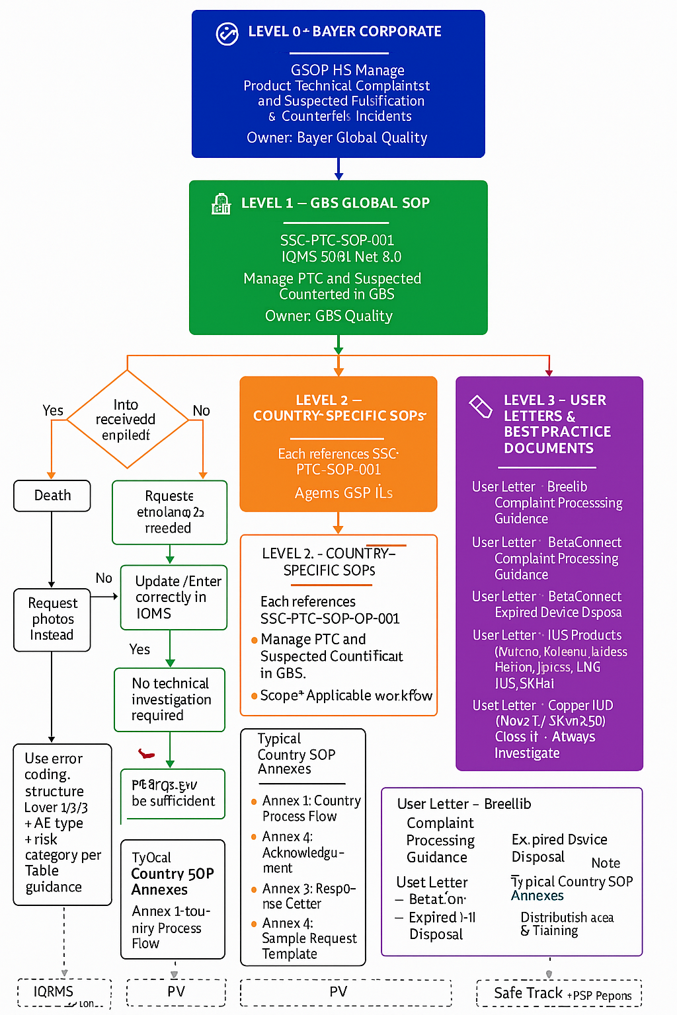

Detailed Narrative of the Hierarchy

🌐 LEVEL 0 — GSOP 115 (Bayer Corporate Global)
GSOP 115 — "Manage Product Technical Complaints and Suspected Falsification and Counterfeit Incidents" is the top-level Bayer corporate standard that establishes the mandatory global requirements for PTC handling across all divisions (PH, CH, Radiology). 48
It defines:
- The global process framework (intake → classification → investigation → closure)
- Risk classification categories (High, Medium, Low) 154
- Timelines for complaint handling (e.g., 24-hour escalation for high-risk) 80
- Roles and responsibilities (CQU, CQH, RQU, PV interface) 85
- Suspected falsification/counterfeit handling requirements 146
Key Annexes:
Annex | Content
Annex 1 | Global Process Flow
Annex 2 | Risk Classification Matrix (High/Medium/Low) 154
Annex 3 | Pick List for Reporting Suspected Falsification & Counterfeit 125
Annex 4 | Definitions & Abbreviations

🏢 LEVEL 1 — SSC-PTC-SOP-001 (GBS Global SOP)
SSC-PTC-SOP-001 (IQMS-50911, Ver. 6.0) — "Manage Product Technical Complaint and Suspected Counterfeit Incidents in GBS" operationalizes GSOP 115 for all GBS locations worldwide. 85
It translates the corporate requirements into GBS-specific operational procedures covering:
- GBS PTC Officer responsibilities (intake, IQMS entry, sample handling, forwarding, closure) 17
- Interface rules with CQU, RQU, and PV 45
- IQMS data entry standards (English language, defined timelines) 150
- Escalation and notification procedures 59
- Mandate for country-specific SOPs to address local variations 41
Key Annexes:
Annex | Content
Annex 1 | GBS PTC Process Flow 85
Annex 2 | Standard Acknowledgement Letter Template 20
Annex 3 | Standard Response Letter Template 20
Annex 4 | RQU Contact List (go/ptcops SharePoint) 153
Annex 5 | Distribution Sheet & Training Roles 18
Applicability across GBS Locations:
- GBS Barcelona, GBS Gdansk, GBS Manila, GBS Dalian, GBS India, GBS Costa Rica/Brazil, GBS Germany 18

📍 LEVEL 2 — Country-Specific SOPs
Each country SOP references both GSOP 115 and SSC-PTC-SOP-001 and adapts the global process to local requirements. 41
Typical structure of each Country SOP (per Best Practice SSC-PTC-BP-002): 41
Section | Content
4.1.1 | Complaint Sources & Intake Channels
4.1.2 | Timelines (country-specific deviations)
4.1.3 | Escalation & Notification Rules
4.1.4 | Acknowledgement & Response Letters
4.1.5 | Product Sample Handling 15
4.1.6 | Response Letter Rules (before/after closing) 16 17
4.1.7 | Out-of-Scope Scenarios
4.1.8 | Local Opportunities Products
4.1.9 | Data Privacy Requirements 19
4.1.10 | Reimbursement / Replacement Rules
4.1.11 | Case Closure Responsibilities
Annex 1 | Country Process Flow
Annex 2 | Acknowledgement Letter (local language)
Annex 3 | Response Letter (local language)
Annex 4+ | Sample Request Templates, Contact Lists
Complete Country SOP Inventory:
Region | Document ID | Country | IQMS | GBS Location
Europe | SSC-PTC-SOP-ES-002 | Spain | IQMS-59667 68 | Barcelona
 | SSC-PTC-SOP-PT-003 | Portugal | IQMS-33695 84 | Barcelona
 | SSC-PTC-SOP-BELUX-002 | Belgium & Luxembourg | IQMS-64489 32 | Barcelona
 | SSC-PTC-SOP-IT-011 | Italy | IQMS-96211 76 | Barcelona
 | SSC-PTC-SOP-DE-012 | Germany | IQMS-60870 83 | Gdansk / Germany
 | SSC-PTC-SOP-FR-015 | France | IQMS-99848 88 | Barcelona
 | SSC-PTC-SOP-UK-IE-MLT-013 | UK, Ireland, Malta | — 21 | Gdansk
 | SSC-PTC-SOP-NO-DK-IS-008 | Norway, Denmark, Iceland | IQMS-97854 61 | Gdansk
 | SSC-PTC-SOP-PL-* | Poland | — 59 | Gdansk
CIS | SSC-PTC-SOP-RU-* | Russia & CIS | — 23 | Gdansk
 | SSC-PTC-SOP-BY-005 | Belarus | IQMS-70232 52 | Gdansk
Middle East | SSC-PTC-SOP-ME-IR-016 | Middle East / Iran | IQMS-95735 54 | Gdansk
Americas | SSC-PTC-SOP-CA-004 | Canada | IQMS-91277 33 | Gdansk
 | SSC-PTC-SOP-US-005 | USA (PH/BT) | IQMS-14847 63 | Costa Rica
 | SSC-PTC-SOP-US-*-CH | USA (CH) | — 11 | Gdansk
APAC | SSC-PTC-SOP-TW-002 | Taiwan | IQMS-58554 34 | Dalian
 | SSC-PTC-SOP-HK-003 | Hong Kong | IQMS-61479 85 | Dalian
 | SSC-PTC-SOP-KR-* | South Korea | — 46 | Dalian
 | SSC-PTC-SOP-ID-* | Indonesia | — 4 | Dalian
Division | SSC-PTC-SOP-RD-* | Radiology (cross-country) | — 60 | Various

📋 LEVEL 3 — User Letters & Best Practice Documents
User Letters provide product-specific or scenario-specific guidance that supplements both the GBS Global SOP and Country SOPs. They are cross-country in nature and apply wherever the relevant product is marketed. 33
Document | Product / Topic | Scope | Key Content
UL – Breelib | Breelib device | AR, AT, CL, DE, IT, PL, PT, UK, CO 38 | PSP flow, Vectura shipment, IQMS coding, treatment stop rules 56
UL – BetaConnect | BetaConnect autoinjector | Countries with Betaferon | LM Phillips-Medisize flow, Safe Track, Scenario 1 & 2 37
UL – BetaConnect Expired | BetaConnect expired devices | Countries with Betaferon | Disposal rules, quarterly LM reporting 55
UL – IUS | Mirena, Kyleena, Jaydess, etc. | Global 44 | Investigation exception rules (Table 2), LODE handling 9
UL – Copper IUD | Nova T / Nova T 380 | Global | Class III: always investigate, photo rules 157
UL – Multiple Manufacturers | Multi-site products | Global 51 | 3-attempt data retrieval, dummy site logic
SSC-PTC-BP-002 | Best Practice | Global 41 | Country-specific SOP template/structure

🔗 Cross-Cutting System Interfaces
System | Role in PTC Process
IQMS (Complaint Database) | Central system for all PTC entries, globally in English 150
Argus / Global Safety Database | PV safety database for PTC+AE cases 125
Safe Track | PSP reporting tool for Breelib and BetaConnect 37
Engage | Local CRM/tracking system (e.g., Canada) 51
go/ptcops SharePoint | RQU contact lists and operational references 153

🔄 Governance & Change Cascade
The document hierarchy follows a strict top-down governance model:
- GSOP 115 changes → trigger mandatory review of SSC-PTC-SOP-001 and all Country SOPs 48
- SSC-PTC-SOP-001 changes → trigger mandatory review of all Country SOPs and User Letters 85
- Country SOP changes → may be triggered by local regulatory changes, CQU requests, or upstream SOP updates 41
- User Letters → updated when product-specific rules change (e.g., new LM, new device version, new investigation exception) 44
Each document includes a version history table and distribution sheet specifying the applicable divisions (PH, CH), GBS locations, and countries.

